Lab 12: Email forensics
What You Need for this lab
  - Install Virtualbox : https://www.virtualbox.org/wiki/Downloads
  - Install Kali 2021.4. : https://old.kali.org/kali-images/kali-2021.4/
    - Notes: Suggest You configure the disk size of Kali VM 80G because the size of each leakage cases image is 30G+
  - Image “cfreds_2015_data_leakage_pc.dd” from Lab 5
Goals
- Email forensics (Application Layer)
Step 1
What application was used for e-mail communication?
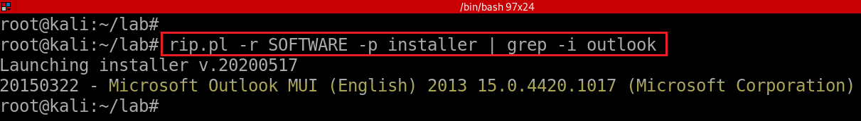
List of email clients
- https://en.wikipedia.org/wiki/Comparison_of_email_clients
What was the e-mail account used by the suspect?
fls -rF -o 206848 cfreds_2015_data_leakage_pc.dd | grep -P "\.ost\$“
fls -rF -o 206848 cfreds_2015_data_leakage_pc.dd | grep -E "\.ost$"
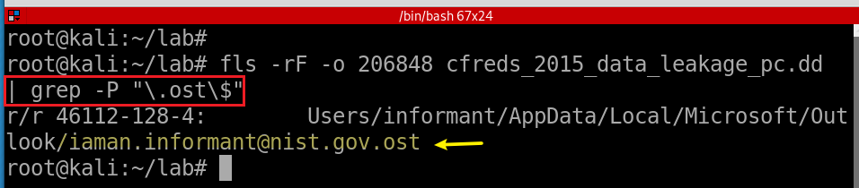
Step 2.
List all e-mails of the suspect. If possible, identify deleted e-mails
- Install email extracting tool: libpff
- Copy .ost file from a DD image
- Extract email via libpff
- Install pffexport tool
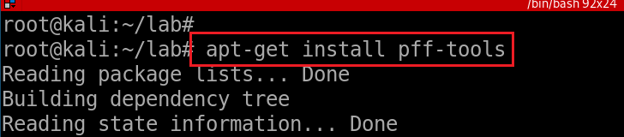
- Verify installation
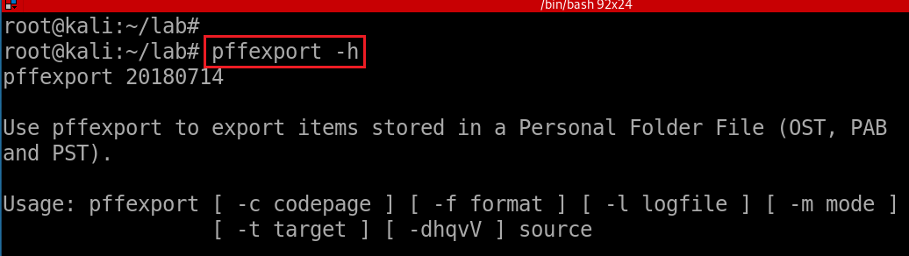
- Copy email to current directory
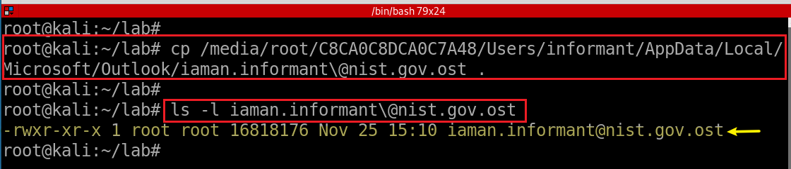
- Extract emails via pffexport
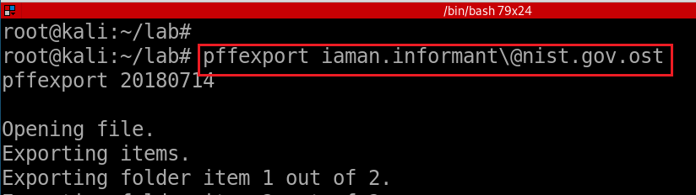
- Verify the default output directory
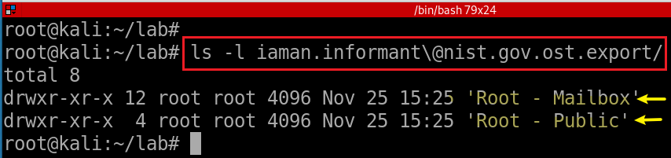
- Access a message in suspect’s Mailbox
ls -l iaman.informant\@nist.gov.ost.export/Root\ -\ Mailbox/

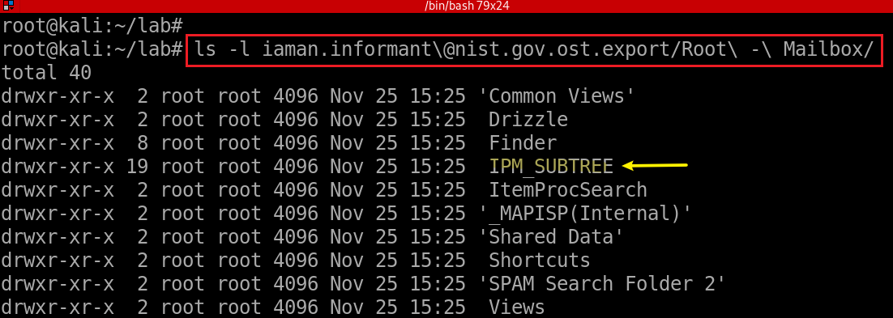
- Access a message in suspect’s IPM_SUBTREE
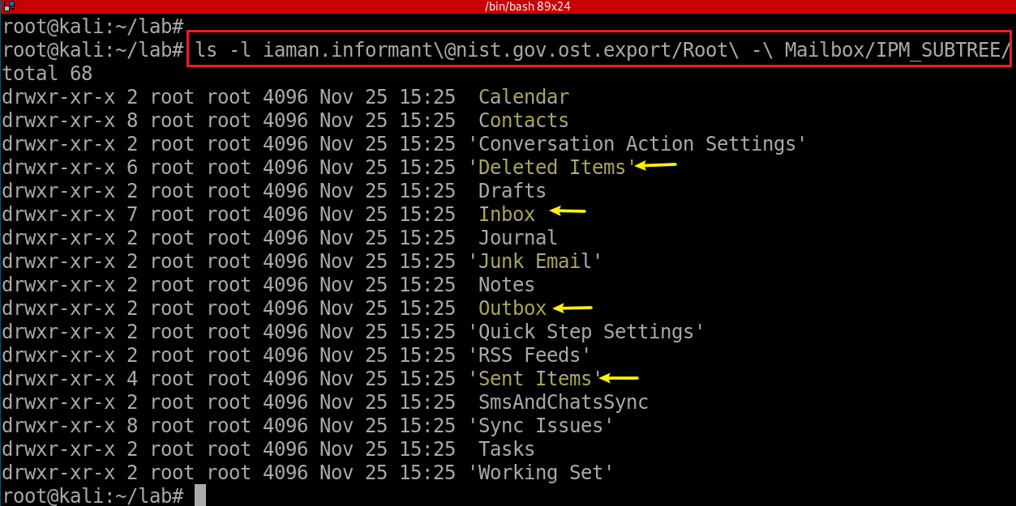
ls -l iaman.informant\@nist.gov.ost.export/Root\ -\ Mailbox/IPM_SUBTREE/Inbox/
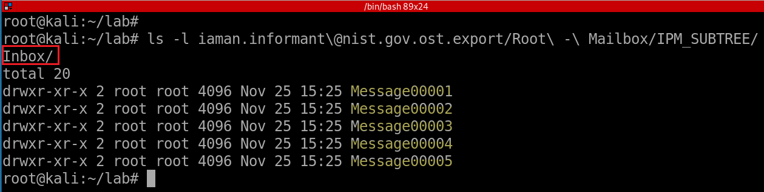
cat iaman.informant\@nist.gov.ost.export/Root\ -\ Mailbox/IPM_SUBTREE/Inbox/Message00001/OutlookHeaders.txt | grep -Ei "time|suject|name“
grep -E ‘strings’ Message*

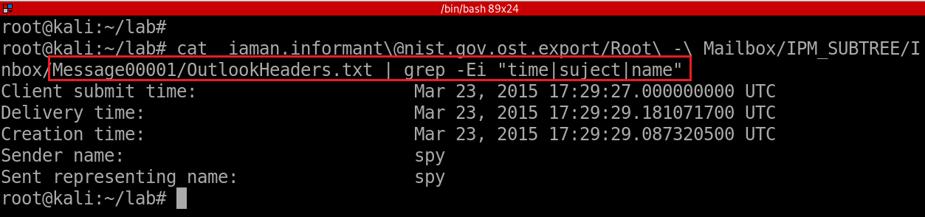

YOU MUST SUBMIT A FULL-SCREEN IMAGE FOR FULL CREDIT!
Save the document with the filename "YOUR NAME Lab 12.pdf", replacing "YOUR NAME" with your real name.
Email the image to the instructor as an attachment to an e-mail message. Send it to: xxx@fe.edu.vn with a subject line of "Lab 12 From YOUR NAME", replacing "YOUR NAME" with your real name.

